

**Faculty of engineering - Shoubra**

**Benha University**

**Research Article / Research Project / Literature Review**

in fulfillment of the requirements of

|  |  |
| --- | --- |
| **Department** | **Engineering Mathematics and Physics** |
| **Division** | **-----------------** |
| **Academic Year** | **2019-2020 Preparatory** |
| **Course name** | **computer** |
| **Course code** | **ECE006** |

**Title: -**

**MOBILE COMPUTING**

By:

|  |  |  |  |
| --- | --- | --- | --- |
|  | Name | Edu mail | B.N |
| 1 | Mohamed Ahmed Eid | Muhammed195728@feng.bu.edu.eg | 653 |

**Introduction:**

Mobile computing and wireless technology usage has grown tremendously in recent years, to the extent where it is considered normal everyday technology in schools and many businesses. For healthcare the opportunities are very exciting and mobile computing could be the answer to the truly “paperless” hospital. In this workshop we will introduce about mobile technology, what it offers, its pitfalls and its future. We will also look at development strategies, implementation strategies and some case studies to determine is mobile computing a lot of hype or really the road to the future. In the end you must decide for yourself because the future is in your hands!

Mobile simply describes a computing device that is not restricted to a desktop. A mobile device may be a PDA, a “smart” cell phone or Web phone, a laptop computer, a tablet PC or any one of numerous other devices that allow the user to complete computing tasks without being physically connected to a network. Mobile computing does not necessarily require wireless communication. In fact, it may not require communication between devices at all. Wireless refers to the method of transferring information between a computing device, such as a personal data assistant (PDA), and a data source, such as an agency database server, without a physical connection. Not all wireless communications technologies are mobile. For example, lasers are used in wireless data transfer between buildings, but cannot be used in mobile communications at this time.

Screenshots:

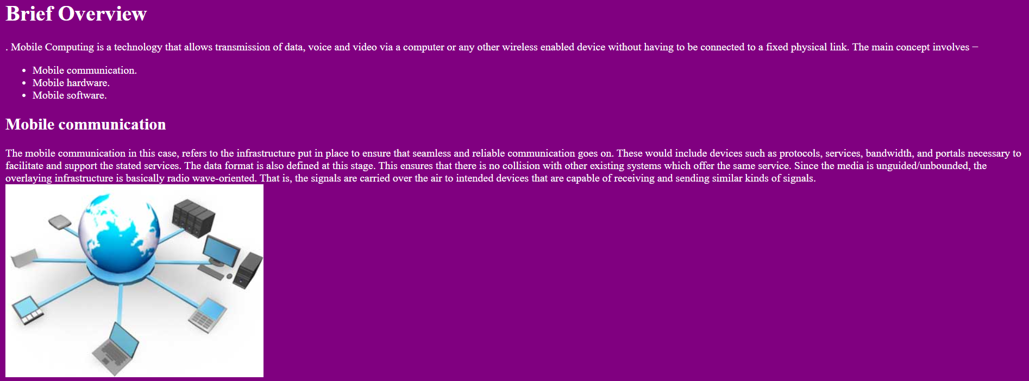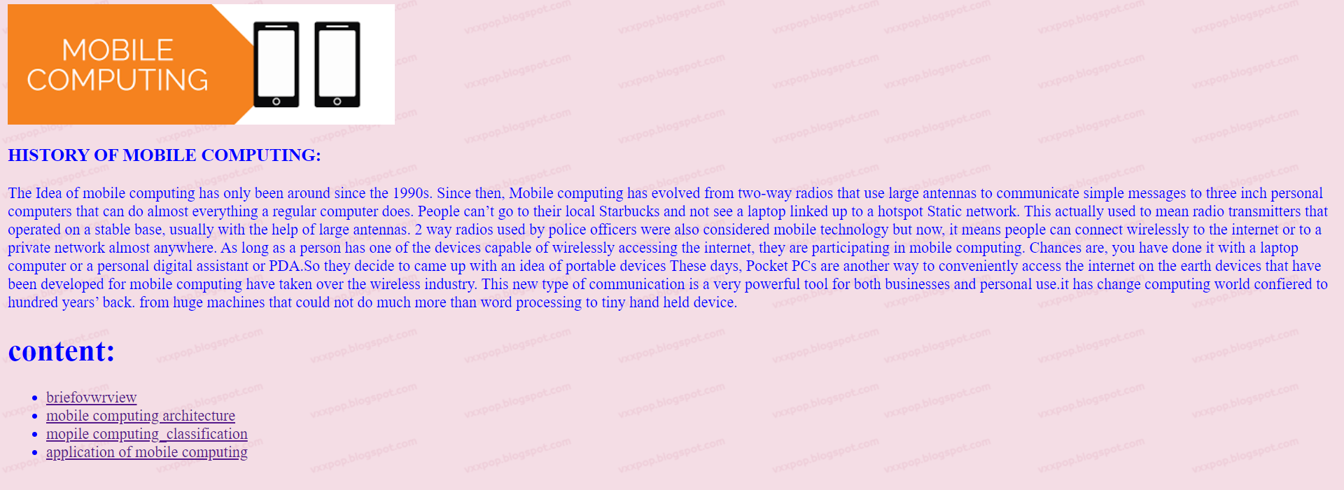

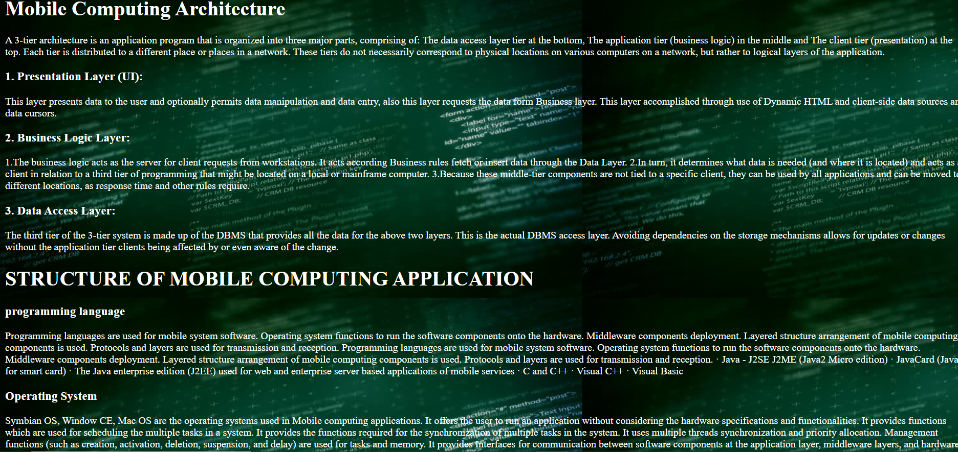

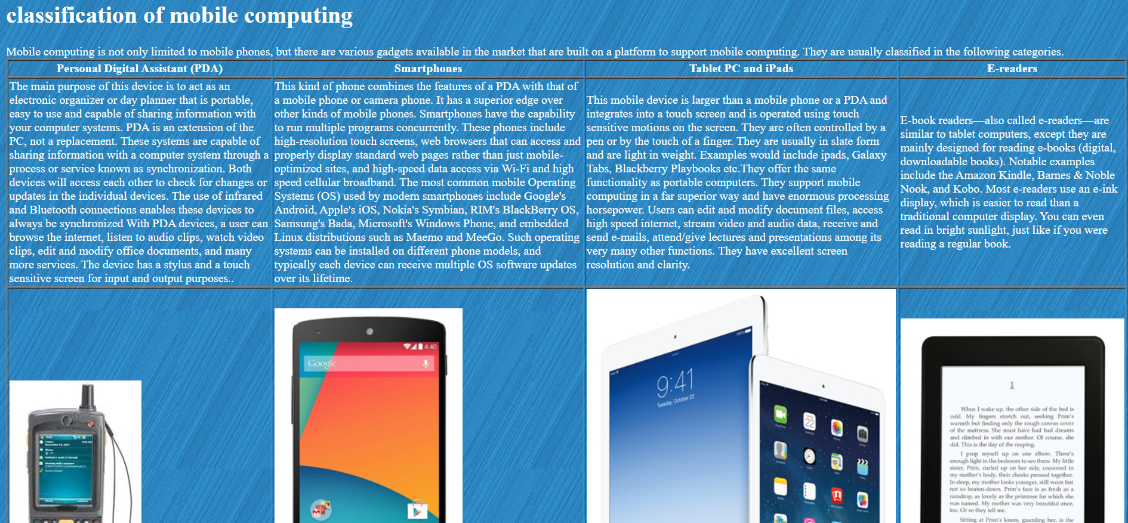

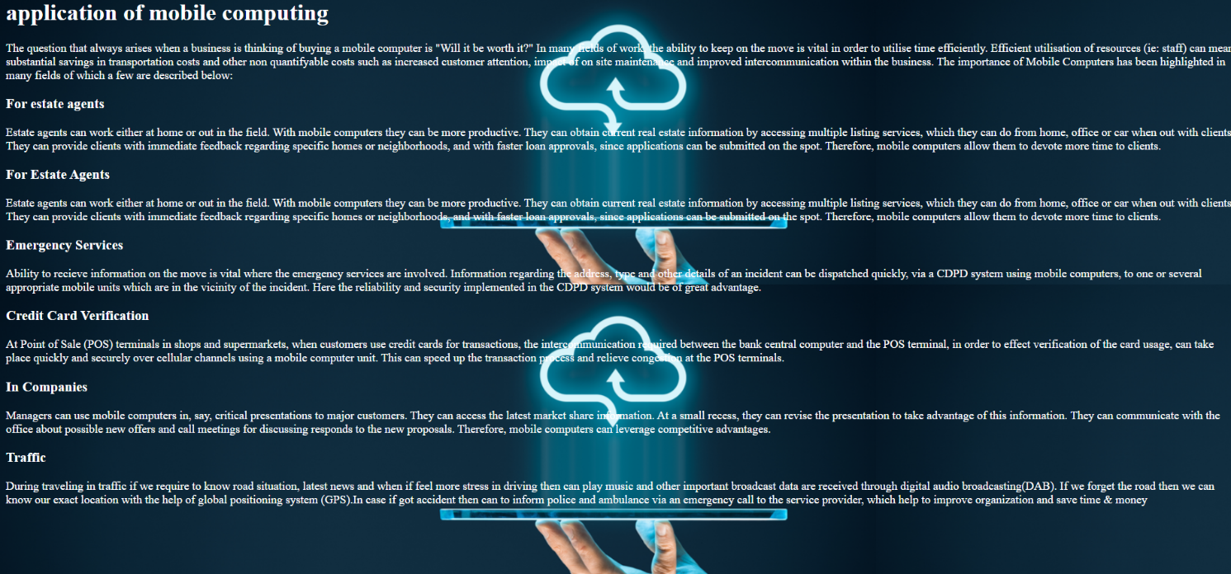

Source code

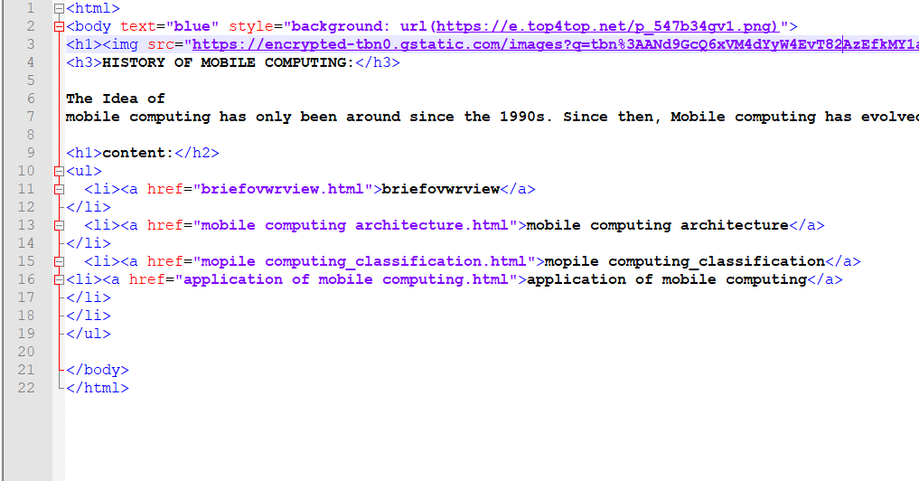

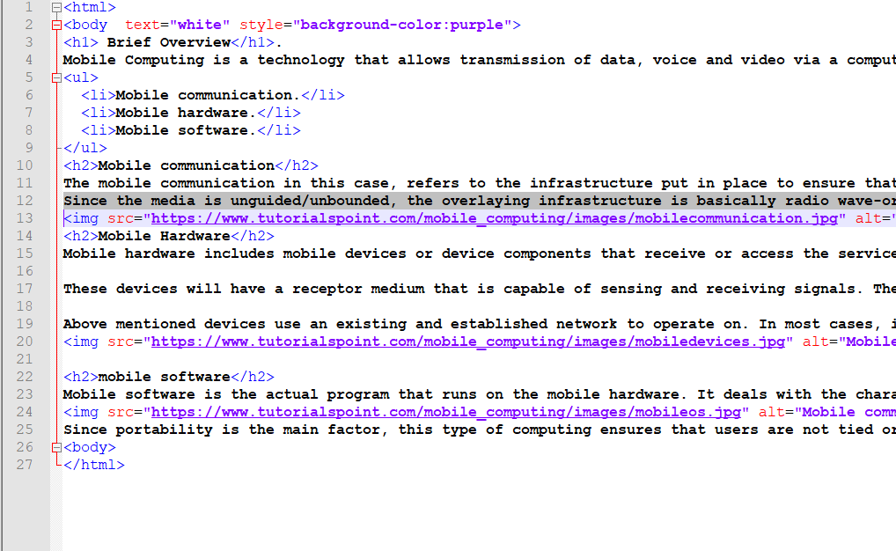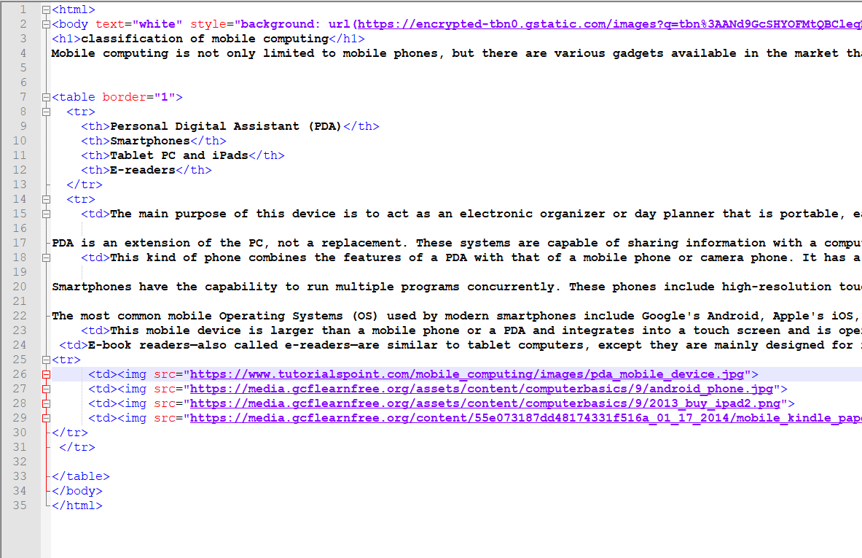

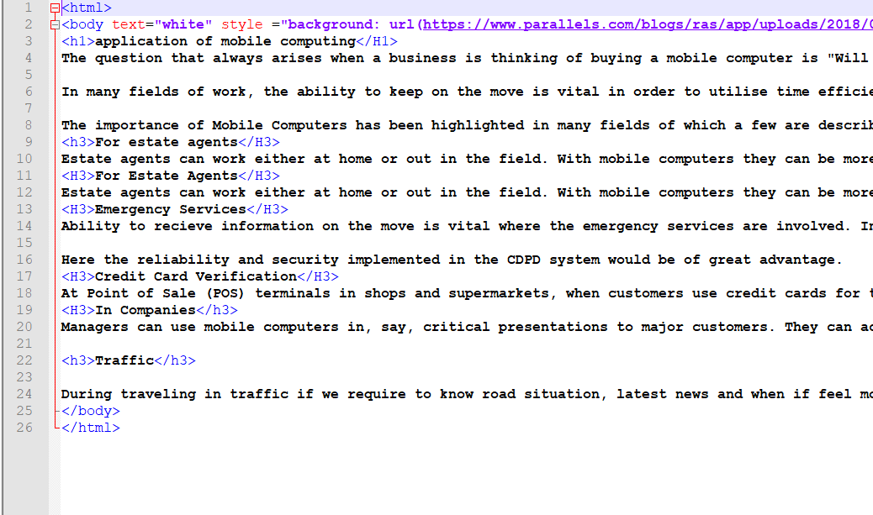

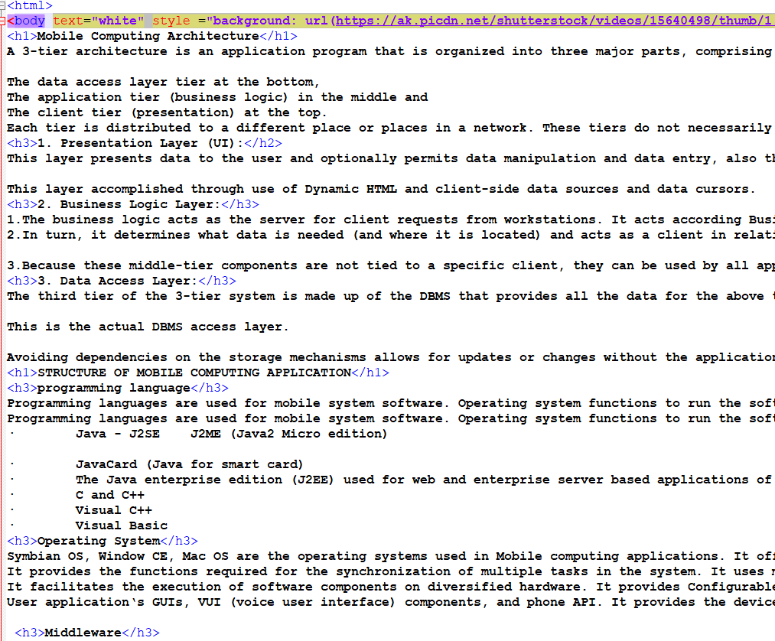

Reference:

|  |
| --- |
| <http://kosmi.snubi.org/APAMI/resource/Tutorials/T2-Leong.pdf> |
| <https://www.wisdomjobs.com/e-university/mobile-computing-tutorial-1415/mobile-computing-classification-25468.html> |
| <https://www.cxotalk.com/episode/future-mobile-computing> |